

obstacle avoidance robot design v1



kareem magdy albolaqi

sprint

9

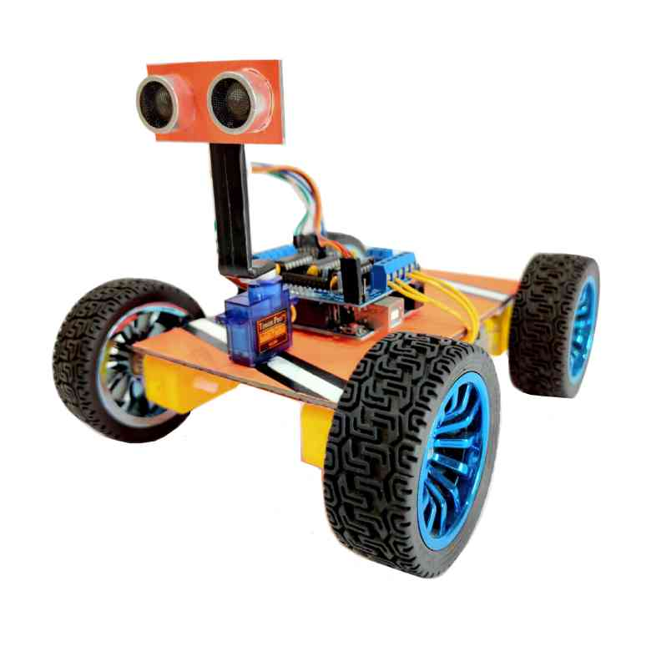

Table of Contents

Project description 2

LAYERD ARCHTICTURE 3

DRIVERS 5

MCAL 5

DIO DRIVER 5

EXTERNAL INTERRUPT 7

TIMER DRIVER 9

ICU DRIVER 11

HAL 12

BUTTON DRIVER 12

KEYPAD DRIVER 13

LCD DRIVER 15

MOTOR DRIVER 18

ULTRASONIC DRIVER 19



* **The car starts initially from 0 speed**
* **The default rotation direction is to the right**
* **Press (Keypad Btn 1), (Keypad Btn 2) to start or stop the robot respectively**
* **After Pressing Start:**

1. The LCD will display a centered message in line 1 “Set Def. Rot.”
2. The LCD will display the selected option in line 2 “Right”
3. The robot will wait for 5 seconds to choose between Right and Left

* **When PBUTTON0 is pressed once, the default rotation will be Left and the LCD line 2 will be updated**
* **When PBUTTON0 is pressed again, the default rotation will be Right and the LCD line 2 will be updated**
* **For each press the default rotation will changed and the LCD line 2 is updated**
* **After the 5 seconds the default value of rotation is set**
* **The robot will move after 2 seconds from setting the default direction of rotation.**
* **For No obstacles or object is far than 70 centimeters:**

1. The robot will move forward with 30% speed for 5 seconds
2. After 5 seconds it will move with 50% speed as long as there was no object or objects are located at more than 70 centimeters distance
3. The LCD will display the speed and moving direction in line 1: “Speed:00% Dir: F/B/R/S”, F: forward, B: Backwards, R: Rotating, and S: Stopped
4. The LCD will display Object distance in line 2 “Dist.: 000 Cm”

* **For Obstacles located between 30 and 70 centimeters**

1. The robot will decrease its speed to 30%
2. LCD data is updated

* **For Obstacles located between 20 and 30 centimeters**

1. The robot will stop and rotates 90 degrees to right/left according to the chosen configuration
2. The LCD data is updated

* **For Obstacles located less than 20 centimeters**

1. The robot will stop, move backwards with 30% speed until distance is greater than 20 and less than 30
2. The LCD data is updated
3. Then preform point 8

**LED SEQUENCE V1.0 PAGE 2**

# Project description

# LAYERD ARCHTICTURE

|  |  |
| --- | --- |
| **UTILITIES** | **APPLICATION** |
| **ECUAL** |
| **MCAL** |
| **MICROCONTROLLER** |

|  |  |
| --- | --- |
| **REGISTERS** | **APPLICATION** |
| **BIT**  **MANIPULATION**  **TYPES** | **ULTRASONIC**  **BUTTON**  **MOTOR**  **KEYPAD** |
| **DIO**  **ICU**  **EXI**  **TIMER** |
| **MICROCONTROLLER** |

# DRIVERS

## MCAL

### DIO DRIVER

Dio_ErrorStatus Dio_init(void);

Dio_ErrorStatus Dio_WriteChannel(Dio_Channel channel , Dio_status state);

Dio_ErrorStatus Dio_ReadChannel(Dio_Channel channel);

|  |  |  |
| --- | --- | --- |
| **DIO_init** | **DIO_write** | **DIO_read** |
|  |  |  |

Configurations :

|  |  |
| --- | --- |
|  |  |

### EXTERNAL INTERRUPT

Ext_intErrorStatus ExtInt_init();

Ext_intErrorStatus INT0_SetCallback(void(*callback)(void));

Ext_intErrorStatus INT1_SetCallback(void(*callback)(void));

Ext_intErrorStatus INT2_SetCallback(void(*callback)(void));

|  |
| --- |
| ExtInt_init(); |
|  |

Configurations :

|  |  |
| --- | --- |
|  |  |

|  |  |
| --- | --- |
|  | |
|  | TIMER DRIVER Timer_ErrorStatus TIMER_init(Timer_Mode mode);  Timer_ErrorStatus TIMER_start(Timer_Prescaler prescaler);  void TIMER_stop(void);  Timer_ErrorStatus TIMER_setIntialValue(uint8_t value);  Timer_ErrorStatus TIMER_OvfNum(uint32 overflow); | |
|  | |  |  |  | | --- | --- | --- | | **TIMER_0_init** | **TIMER_0_start** | **TIMER_OvfNum** | |  |  |  | | |

Configurations :

|  |  |
| --- | --- |
|  |  |

|  |  |
| --- | --- |
|  | |
|  | ICU DRIVER Icu_ErrorStatus ICU_init();  Ext_intErrorStatus INT0_SetCallback(void(*callback)(void)); | |
|  | |  |  | | --- | --- | | ICU_init() | **CALLBACK FINCTION** | |  |  | | |

**Configurations :**

WE CAN USE DIO AND EXI CONFIGURATION TO SET OUR ICU DRIVER CONFIGURATION

## HAL

### BUTTON DRIVER

Dio_ErrorStatus BUTTON_read(PORT_NUM portnum ,PIN_NUM pinnum, uint8_t *value);

|  |
| --- |
| **BUTTON_read** |
|  |

**Configurations :**

WE CAN USE DIO AND EXI CONFIGURATION TO SET OUR BUTTON DRIVER CONFIGURATION

### KEYPAD DRIVER

uint8_t KEYPAD_getKey(void);

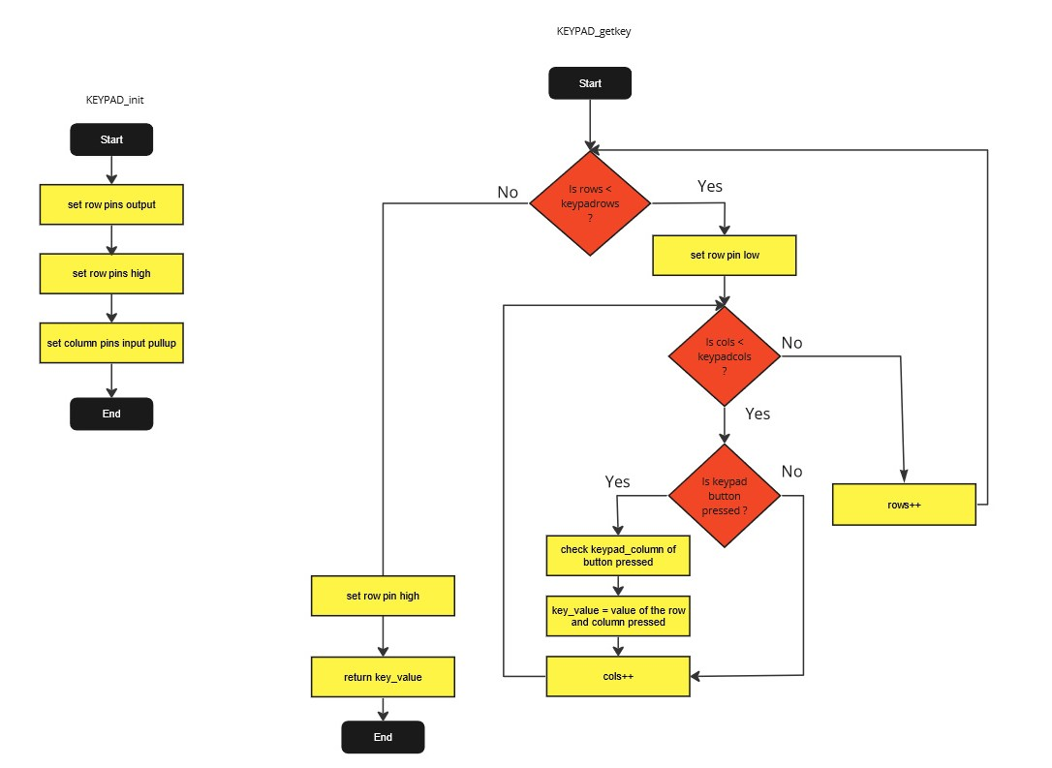

**Configurations :**

WE CAN USE DIO TO SET OUR KEYPAD DRIVER CONFIGURATION

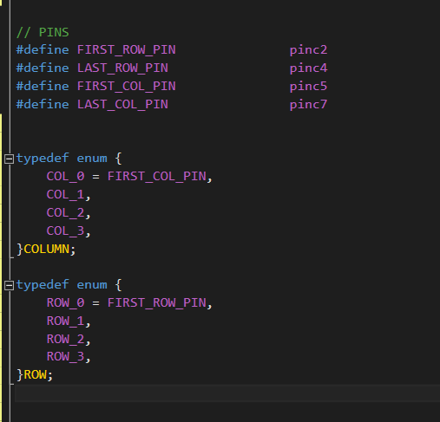

### LCD DRIVER

void LCD_WRITE_COMMAND(uint8_t a_COMMAND);

void LCD_WRITE_DATA(uint8_t a_DATA);

void LCD_INIT(void);

void LCD_Clear(void);

void LCD_GoTo(uint8_t a_line,uint8_t a_cell);

void LCD_Write_Charecter(uint8_t a_char);

|  |  |  |  |
| --- | --- | --- | --- |
|  |  |  | |
|  |  | |  |

**Configurations :**

WE CAN USE DIO TO SET OUR KEYPAD DRIVER CONFIGURATION

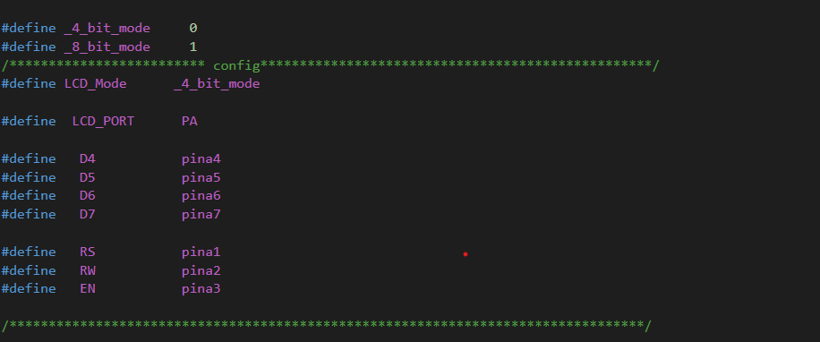

### MOTOR DRIVER

void Car_Moving_FWD(void);

void Car_Rotating(void);

void Car_Stop(void);

|  |  |  |
| --- | --- | --- |
|  |  |  |

**Configurations :**

WE CAN USE DIO TO SET OUR KEYPAD DRIVER CONFIGURATION

### ULTRASONIC DRIVER

void get_Distance(uint_8 * a_distance);

